**DAILY ONLINE ACTIVITIES SUMMARY**

|  |  |  |  |  |  |  |  |  |
| --- | --- | --- | --- | --- | --- | --- | --- | --- |
| **Date:** | **05-07-2020** | | | | | **Name:** | **Anix Jugal D’Cunha** | |
| **Sem & Sec** | **8 sem , A sec** | | | | | **USN:** | **4AL16CS013** | |
| **Online Test Summary** | | | | | | | | |
| **Subject** | | **Not Conducted** | | | | | | |
| **Max. Marks** | | **--** | | **Score** | | | **--** | |
| **Certification Course Summary** | | | | | | | | |
| **Course** | Learn Advanced HTML5 | | | | | | | |
| **Certificate Provider** | | | **Udemy** | | **Duration** | | | 2 hours |
| **Coding Challenges** | | | | | | | | |
| **Problem Statement:** program to find the XOR of all elements in the array Function | | | | | | | | |
| **Status: Competed** | | | | | | | | |
| **Uploaded the report in Github** | | | | | **yes** | | | |
| **If yes Repository name** | | | | | **alvas-education-foundation/dcunhaanixjugal** | | | |
| **Uploaded the report in slack** | | | | | **yes** | | | |

Online Test Details: (Attach the snapshot and briefly write the report for the same)

**Not Conducted**

Certification Course Details: (Attach the snapshot and briefly write the report for the same)

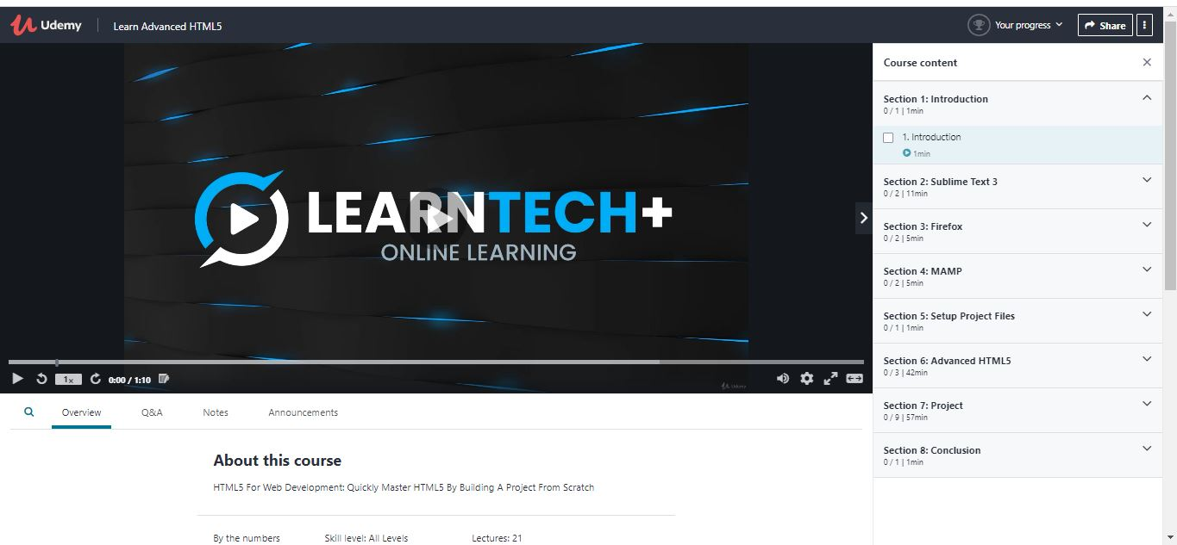

Coding Challenges Details: (Attach the snapshot and briefly write the report for the same)

## Program-> Python3 program to find the XOR of all elements in the array Function

|  |
| --- |
|  |

## def xorOfArray(arr, n):

## 

## xor_arr = 0

## 

## for i in range(n):

## 

## xor_arr = xor_arr ^ arr[i]

## 

## return xor_arr

## 

## if __name__ == '__main__':

## arr = [3, 9, 12, 13, 15]

## n = len(arr)

## print(xorOfArray(arr, n))